**Chapter 4: Periodic Table and Periodicity of Properties**

**All Lectures Uploaded on YouTube:**

[**https://tinyurl.com/fkm9-chemistry**](https://tinyurl.com/fkm9-chemistry)



Only 23 elements were known until the end of the 18th century, to its development of 118 elements today. It is very difficult and impossible to remember information about the reactions, properties, and atomic masses of elements. So, we obviously need a way to organize our information about them.

The periodic table is one of the most important tools in chemistry. It is very useful for understanding and predicting the properties of elements. For example, if you know the physical and chemical properties of one element in a group, you can predict the physical and chemical properties of any other element in the same group. The periodic table allows you to relate the reactivity tendencies of elements to their atomic structure. You can also predict which elements can form ionic or covalent bonds.

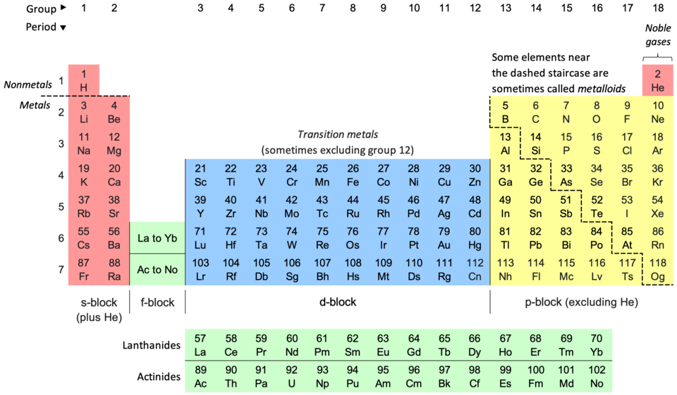

**4.1. Periodic Table**

After the discovery of atomic number by Moseley in 1913, it was noticed that atomic number could serve as a base for systematic arrangement of elements. Thus, elements are arranged in the order of increasing atomic number.

A table showing systematic arrangement of elements is called a periodic table. It is based on the Periodic law that states if the elements are arranged in the order of their increasing atomic numbers, their properties are repeated in a periodic manner.

**4.1.1. Periods and Groups of Elements**

**The horizontal rows of the periodic table are called periods.** There are varying numbers of elements in periods.

There are seven periods. The number of elements per period range from 2 in period 1 to 32 in period 6. The first three periods are called short periods, and the remaining periods are called long periods. The properties of elements within a period change gradually as you move from left to right in it. But when you move from one period to the next, the pattern of properties within a period repeats. This is in accordance with the periodic law.

The International Union of Pure and Applied Chemistry discovered elements and placed them on the periodic table. has recently renamed newly elements that have similar properties lie in the same column in the periodic table.

**Each vertical column of elements in the periodic table is called a group or family.**

Two numbering systems are often used to designate groups. 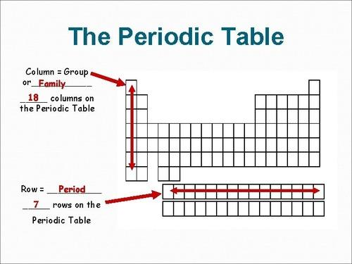

In the traditional system and the old IUPAC, the letters A and B are used. The first two groups are IA and IIA, while the last six groups are IA to VIIIA and the middle groups are in group B. The International Union of Pure and Applied Chemistry (IUPAC) decided that the groups would be 1-18 from left to right.

The elements in the same group have the same number of valence electrons. Group number indicates the number of valence electrons in an element.

Group A elements are called normal or representative elements. They are also called main group elements. Group B elements are called transition elements.

**Names of Some Groups in the Periodic Table**

Some groups of elements in the periodic table have been given group names.

* Metallic elements in Group 1 are called alkali metals.
* Group 2 elements are called alkaline earth metals.
* The elements in Group 17 or VIA are called halogens.
* The Group 18 or VIIIA elements are called noble gases because they do not readily undergo chemical reactions.

**Electronic Configuration**

According to Aufbau's principle, the order in which the orbitals fill up is as follows: 1s,2s,2p,3s,3p,4s,3d, 4p, 4p,5s,4d,5p, 6s and so on

Each orbital has a fixed capacity for the maximum number of electrons accommodated

* s-orbitals have the capacity of 2 electrons
* p orbitals have the capacity for 6 electrons
* d orbitals have the capacity for 10 electrons
* F orbitals have the capacity for 14 electrons.

**Block of an element:**

When you have filled all the electrons, the orbital in which the last electron is in, represents the block in which the element is placed.

**Period of an element:** The period in which the element is placed, you need to look at the principal quantum number(n) of the valence electron. This number represents period number of element

**Group of an element:**

To determine the group, we need to understand some rules:

* If the element is in s block, then the group number is equal to the number of valence electrons.
* If the element is in the p block, then the number of the group can be determined by the formula: (number of valence electrons + 10).

**S and P Blocks in the Periodic Table**

* Group 1 and Group 2 elements contain their valence electrons in the s sub-shell. Therefore, these elements are called s-block elements.
* Elements in groups 13 to 18 (except He) are known as p block elements because their valence electrons are in the p sub-shell.
* Lanthanides and actinides are known as f-block elements since their valence electrons lie in f sub-shell.

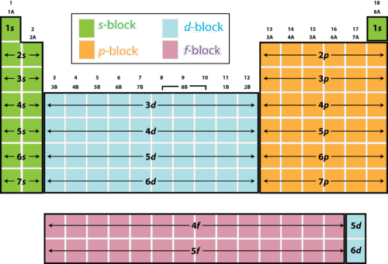

**4.2. Group Number And Charge On An Ion**

The group number of an element in the periodic table can provide information about the charge of an ion formed by an element. Valence electrons are involved in the formation of ions. The relationship between group number and ions formed by elements is based on the number of valence electrons in the element.

* The group number of an s-block element in the periodic table corresponds to its number of valence electrons.
* Whereas in the case of p-block elements, the number of valence electrons is equal to Group number minus 10.

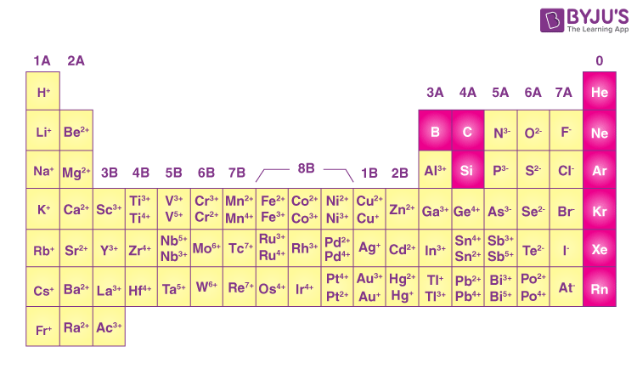Some elements tend to lose electrons. Because elements tend to achieve a stable electron configuration such as the noble gases. Remember that the 2 or 8 electron configuration is the most stable configuration.

* Elements with 1-3 electrons in their valence shell tend to lose those electrons and form

+1, +2, +3 ions respectively.

* Elements with 5-7 electrons in their valence shell tend to gain 3, 2, 1 electrons respectively and form negatively charged ions with -3, -2, -1 charges respectively.
* Elements with 4 valence electrons can lose 4 electrons to form +4 tons. They can also gain 4 electrons and form-4ions.

**Group 1 (alkali metals)**: Group 1 elements such as lithium (L), sodium (Na), and potassium (K) have one valence electron and belong to s block. S block elements lose electrons equal to their group number.

**Group 2 (alkaline earth metals):** Group 2 elements such as beryllium (Be), magnesium (Mg), and calcium (Ca) have two valence electrons and are s block element. They tend to lose these two electrons to form + 2 ions, also called divalent cations.

**Halogens:** Group 17 elements such as fluorine (F), chlorine (Cl), and bromine (Br) have seven valence electrons. They tend to gain one electron to reach a stable octet and form - 1 ion, also called a monovalent anion.

For example: Fluorine (F) gains one electron to form F. Chlorine (Cl) gains one electron to form Cl. Bromine (Br) gains one electron to form Br.

**Group 16 (chalcogens)**: Group 16 elements such as oxygen (0), sulfur (S), and selenium (Se) have six valence electrons. They tend to gain two electrons to reach a stable octet and form a -2 lon, also called a divalent anion.

For example: Oxygen (0) gains two electrons to form 02 Sulfur (S) gains two electrons to form S

**Group 18 (precious gases):** Group 18 elements such as helium (He), neon (Ne), and argon (Ar) have full valence electron shells (except helium, which has only two valence electrons).

They are chemically stable and do not form ions under normal conditions. Noble gases are known for their low reactivity due to their stable electronic configuration.

**4.3. Periodicity of Properties**

* As atomic number increases, elements show **periodic** changes in properties.
* Elements in the **same group** have similar **valence-shell electron configurations**, so they show **similar chemical properties**.
* **Physical properties** change gradually down a group because **atomic size changes**.
* Across a **period**, the number of valence electrons increases, so both physical and chemical properties change in a predictable way.

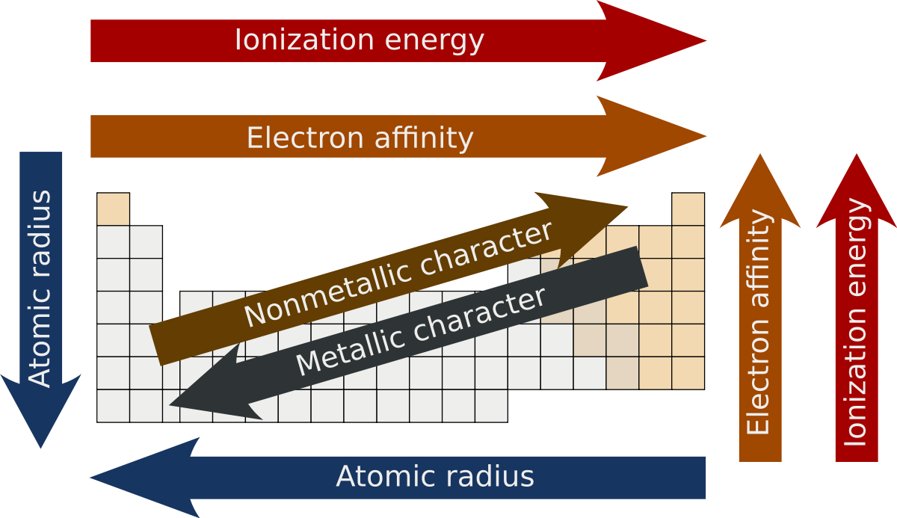

## 4.3.1. Shielding Effect

* Inner-shell electrons reduce the attraction between the nucleus and valence electrons. This is called the **shielding effect**.
* **Down a group:** number of shells increases → more inner electrons → **shielding increases**.
* **Across a period:** inner shells stay the same → **shielding stays almost constant**.

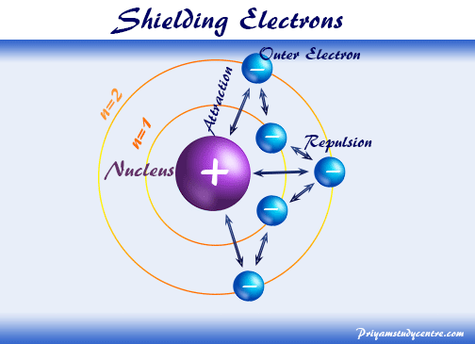

## 4.3.2. Atomic Size

* Atomic size = average distance between nucleus and outermost shell.
* **Across a period:** atomic radius **decreases** because nuclear charge increases while electrons enter the same shell → stronger attraction.  
  + Example: Li → Be (size decreases).
* **Down a group:** atomic radius **increases** because a new electron shell is added for each lower element.  
  + Example: Li → Na (size increases due to extra shell).

## 4.3.3. Ionization Energy

* Ionization energy = **energy needed to remove the outermost electron** from a gaseous atom.
* High IE = strong nuclear attraction; low IE = weak attraction.
* **Down a group:** IE **decreases** due to increased shielding → electrons are easier to remove.
* **Across a period:** IE **increases** because nuclear charge increases while shielding stays constant → electrons held more strongly.

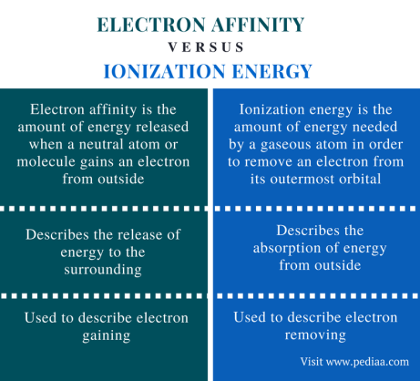

## 4.3.4. Electron Affinity

* Electron affinity = **energy released when an atom gains an electron** to form a negative ion.
* Depends on nuclear charge, atomic size, and shielding.
* **Across a period:** generally **increases** (atoms hold the added electron more strongly).  
  + Halogens = highest; alkali metals = lowest.
* **Down a group:** **decreases** because larger size and greater shielding reduce attraction for the extra electron.

## 4.3.5. Electronegativity

* Electronegativity = **ability of an atom to attract electrons in a chemical bond**.
* Pauling developed the method for calculating electronegativity values.

**4.4. Characteristic Properties**

* Elements in each group show characteristic properties due to periodicity and similar reactivity.
* Example: **Group 1 (alkali metals)**—Li, Na, K—are highly reactive metals with general configuration **ns¹**.
* Reactivity **increases down the group** because atomic size increases and the outer electron is more easily lost.

## 4.4.1. Metallic Character

* Metallic character = **tendency of an element to lose electrons and form cations**.
* **Down a group:** metallic character **increases** due to more shells and weaker attraction on valence electrons.
* **Across a period (left → right):** metallic character **decreases** because nuclear charge increases and holds electrons more strongly.

## 4.4.2. Reactivity

* Reactivity = how easily an element forms compounds.
* **Down a group:** reactivity **increases** as atomic size increases and electrons are less tightly held.
* **Across a period:** varies:  
  + Left side (Groups 1 & 2): highly reactive metals (lose electrons).
  + Right side (Groups 16 & 17): highly reactive nonmetals (gain electrons).

## 4.4.3. Density

* **Down a group:** density **increases** due to greater atomic mass and larger atoms.
* **Across a period:** density generally increases to a maximum in the middle, then decreases.

## 4.4.4. Characteristic Properties of Alkali Metals

* Very **high reactivity**, forming **+1 cations**.
* **Soft**, **low-density** metals; softness increases down the group.
* Good **conductors** of heat and electricity.
* **Low melting points**.
* Always **monovalent** (one valence electron).

## 4.4.5. Predicting Properties of Other Group 1 Elements

* Group 1 metals (Li, Na, K) are soft, reactive, and show trends in melting point and reactivity.
* **Melting and boiling points decrease down the group.**
* Reaction with water:  
   **metal + water → salt + hydrogen**
* Reactivity with water **increases down the group**.

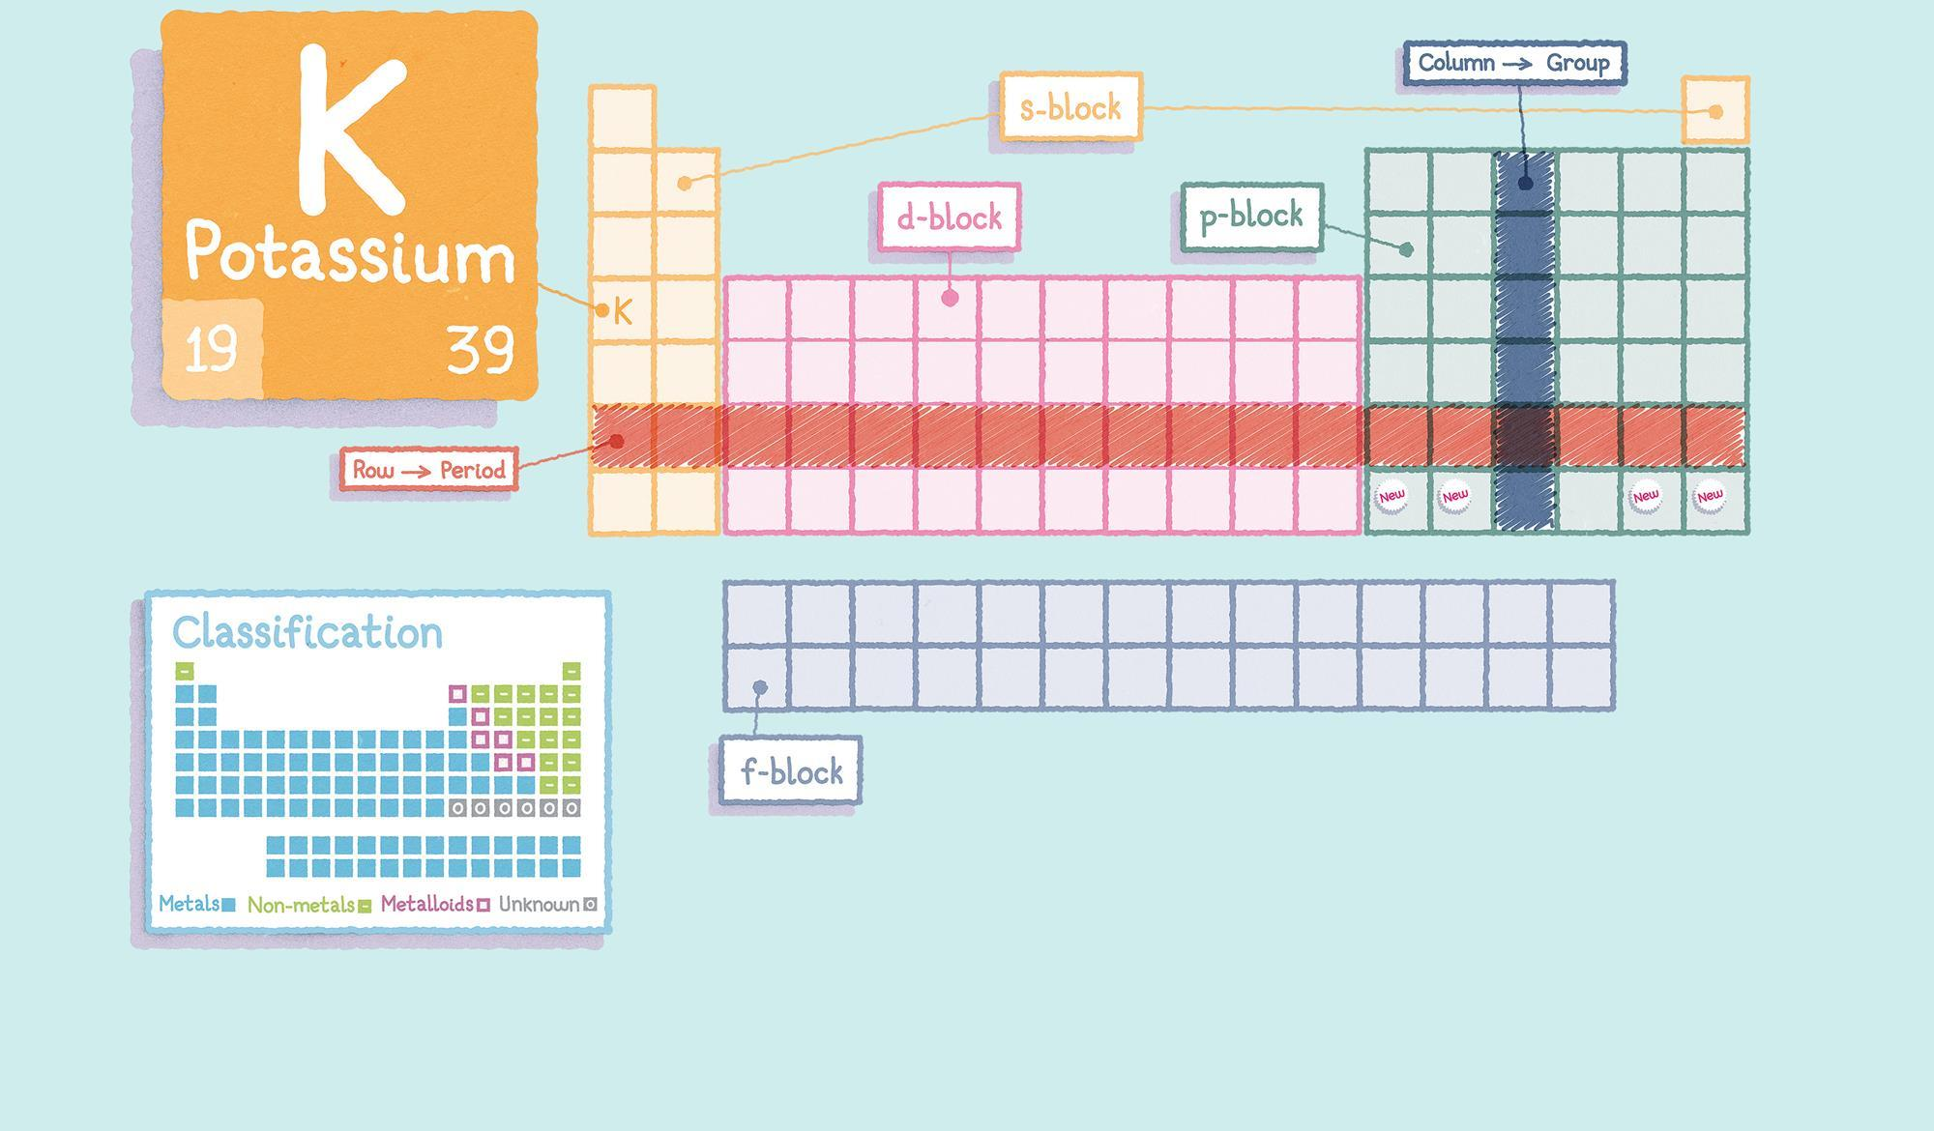

## 4.4.6. Position of an Unknown Element in the Periodic Table

* Electronic configuration determines position and properties.
* Elements in the same group have similar configurations and similar chemical behavior.
* By analyzing **periodic trends** (atomic size, IE, electron affinity, electronegativity, reactivity), one can predict an element's position.
* Example: An element with **4s¹** must be a **Group 1 alkali metal** in the **4th period**.
* Its properties (melting point, density, reactivity) can be predicted by comparing it with elements above and below it.

**4.5. Transition Elements**

Transition elements are located in the **d-block (Groups 3–12)** and have several characteristic properties that distinguish them from other elements.

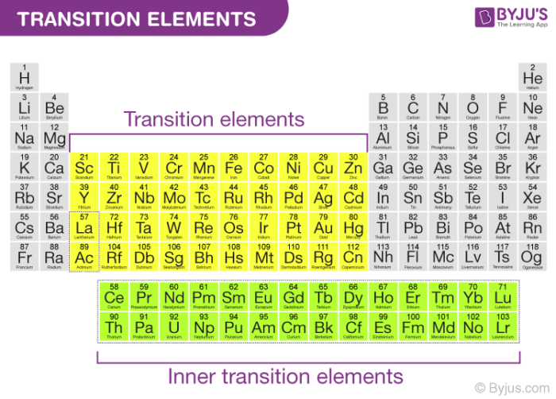

### 1. High Density

* Transition elements have **high densities** because of their **large atomic masses** and **closely packed structures**.  
  + Examples: Fe = 7.87 g/cm³, W = 19.3 g/cm³.

### 2. High Melting Points

* They have **high melting points** due to **strong metallic bonding**, which results from **partially filled d-subshells**.  
  + Examples: W melts at 3422°C, Pt at 1768°C.

### 3. Variable Oxidation States

* They show **multiple oxidation states** because both **s and d electrons** can participate in bonding.  
  + Examples: Fe (+2, +3), Cu (+1, +2).

### 4. Colored Compounds

* Many transition metal compounds are **colored**, often showing vivid blues, greens, and reds.  
  + Examples: Cu compounds → blue/green; Cr compounds → red/green.

### 5. Catalytic Properties

* Transition metals and their compounds act as **important industrial catalysts**.  
  + Fe → Haber Process (ammonia).
  + Pt & Pd → catalytic converters.
  + Ni → hydrogenation (margarine).
  + Pt → Contact Process (sulphuric acid).

**4.6. Lanthanides & Actinides**

Lanthanides also known as "rare earth elements" are a series of 14 elements located at the bottom of the periodic table. They include elements with atomic number 57 to 71.

Actinides are another series of 14 elements located just below lanthanides. They include elements with atomic number 89 to 103.

**4.7. Halogens**

Halogens (Group 17 / VII-A) include **F, Cl, Br, I, At, Ts**.  
 They are **reactive non-metals**, exist as **diatomic molecules**, and form salts.

## 4.7.1 Appearance

* All halogens are **colored diatomic molecules**.
* Color **darkens down the group**.  
  + **F₂**: pale yellow gas
  + **Cl₂**: yellow-green gas
  + **Br₂**: red-brown liquid
  + **I₂**: black solid (purple vapor when heated)

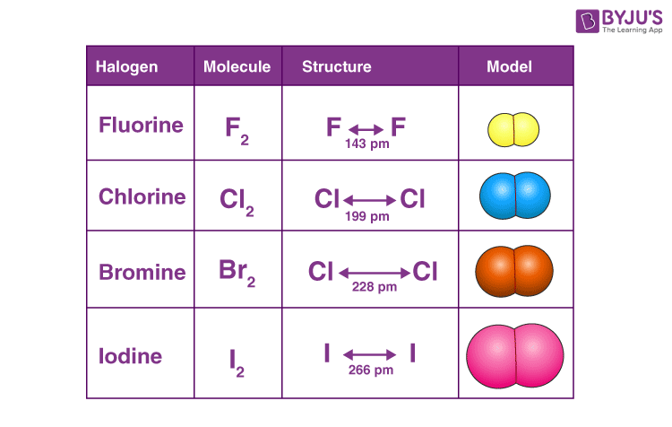

## Electronic Configuration

* Valence electrons = **7** → configuration **ns² np⁵**.
* Need **one electron** to complete the octet → form **–1 ions** (F⁻, Cl⁻, Br⁻, I⁻).

## Density

* Density **increases down the group** because:  
  + Atomic mass increases more than volume.
  + Intermolecular forces increase (gas → liquid → solid).
* F₂ and Cl₂ = gases, Br₂ = liquid, I₂ = solid.

## Reactivity

* Reactivity depends on ability to **gain an electron** (form halide ions).
* **Electronegativity decreases down the group** → reactivity decreases.
* **Most reactive:** F₂
* **Least reactive:** I₂
* Order of **oxidizing power**:  
   **F₂ > Cl₂ > Br₂ > I₂**

## Displacement Reactions

* A more reactive halogen displaces a less reactive halide from solution.
* F₂ can displace Cl₂, Br₂, and I₂ from their salts.  
   Examples:  
   **F₂ + 2KCl → 2KF + Cl₂** **F₂ + 2KBr → 2KF + Br₂**

## Hydrogen Halides & Thermal Stability

* Halogens react with hydrogen: **H₂ + X₂ → 2HX**.
* Bond strength depends on electronegativity difference.
* Electronegativity decreases from F to I → bond strength and stability decrease.
* **Thermal stability order:** **HF > HCl > HBr > HI**

## Predicting Properties of Group 17 Elements

* Halogens are **poisonous non-metals** with **low melting and boiling points**, increasing down the group.
* Physical state changes down the group:  
   **gas → gas → liquid → solid** (F₂, Cl₂, Br₂, I₂).
* Their **colors darken** from top to bottom.

**4.8. Noble Gases**

* Noble gases are found in **Group 18 (Group VIII-A)** of the periodic table.
* They have a **complete valence shell** with the general configuration **ns² np⁶**, except **helium**, which is **1s²**.

### Properties

* They are **monoatomic**, **colorless**, **odorless** gases.
* They show **very low reactivity** because their electron shells are completely filled, making them **stable** and unlikely to form bonds.

### Elements

* Helium (He), Neon (Ne), Argon (Ar), Krypton (Kr), Xenon (Xe), Radon (Rn), Oganesson (Og).

### Uses

* Used in **lighting** (neon signs), **refrigeration**, **welding**, and **shielding gases** for industrial processes.
* Their non-reactive nature makes them suitable for **safe, stable environments** such as gas fillings and protective atmospheres.

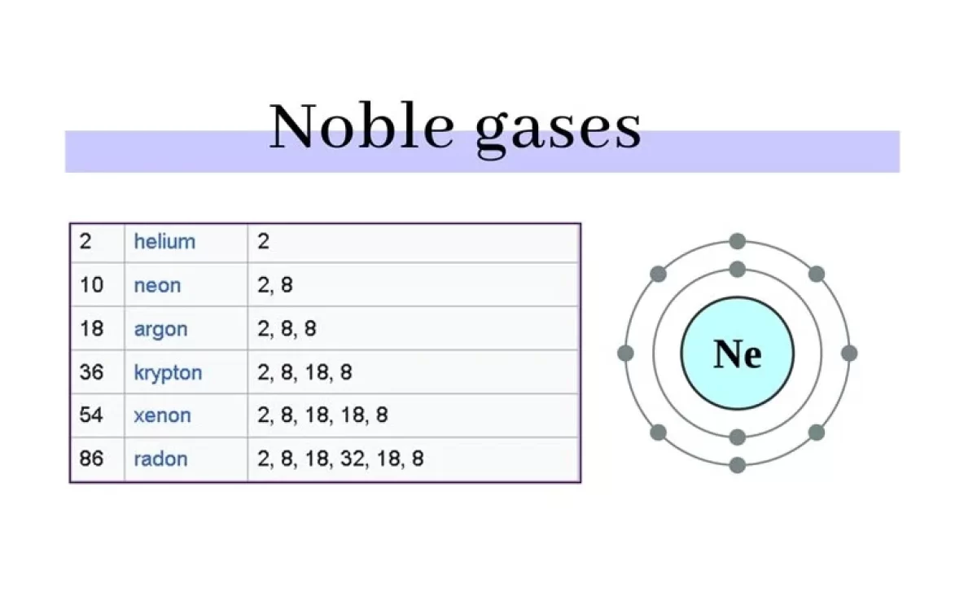

**4.9. Comparison Of General Physical Properties Of Metals And Non-Metals**

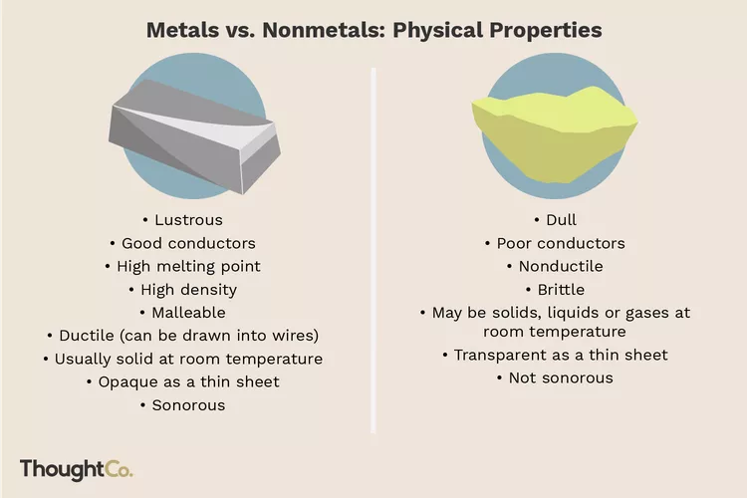

**Thermal Conductivity:** Metals generally have high thermal conductivity, which means they can conduct heat easily. On the other hand, non-metals tend to have poor conductivity, making them less efficient at conducting heat.

**Electrical Conductivity:** Metals are good conductors of electricity, because they have free electrons that can move freely in the metal lattice. Non-metals, with few exceptions such as graphite, are poor conductors of electricity because they lack free electrons.

**Adaptability:** The metals are malleable and ductile. So, they can be hammered, drawn into wires or transformed into thin sheets without breaking. This property is due to metallic bonds which allow atoms exchange easily under pressure. Non-metals are neither malleable nor ductile, rather they are brittle.

**Melting Points and Boiling Points:** Metals generally have high melting points and boiling points due to strong metallic bonds that require a lot of energy to break. On the other hand non-metals often have lower melting points and boiling points because their atoms and molecules are held by weaker bonds such as covalent bonds, van derWaals bonds, or hydrogen bonds that require less energy to break.

